Name
Professor
Title
Date
Playground Activity
Playground Name
City Park – Woodland, California
Young Child Aged 1-5 Years
There are playing equipment and design that would appeal to this age ground. This is the age ground that love swinging and the playground has such equipment for them. In addition, they also like moving up and down ladders and this has also been taken care of in the park design by the climber playset equipment.
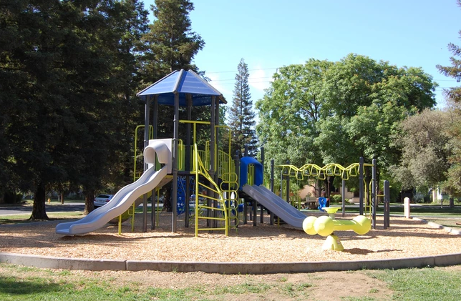
Middle Age Children (Ages 5 and Up)
This age group like playing in a group and are very fond of showing off in their group about their skills and bravery. They would, therefore, like to have a swinging play like the seesaw in order to display how grown they are compared to their friends. In addition, the swing and slide equipment would also appeal to them as they try to take turns in climbing and sliding off the climber playset.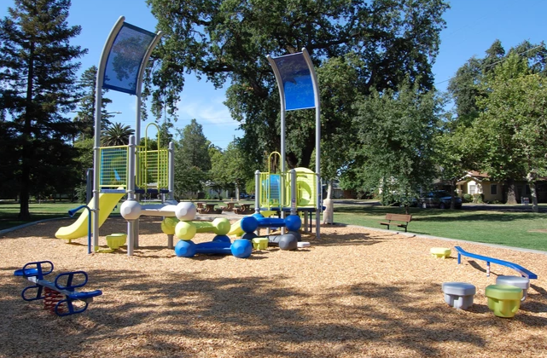
Accessibility
The playground is accessible to everyone since it is a community playground. Even those who have a disability like wheelchairs and other walking aids can access and use the park for playing and recreational purpose. This is because it is located in a place where there are no obstacles like climbing required to access the facility.
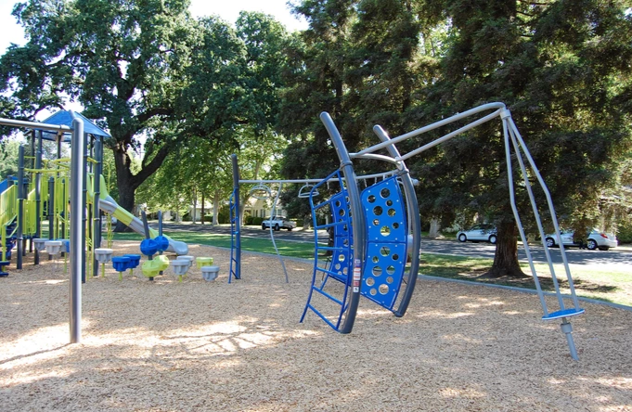
Other Amenities and Recommendations
The place is surrounded by a serene cool play with trees. This provides shade for everyone especially the parents and caregivers who watch their children as they enjoy themselves playing. Besides, there is ample parking space which has been preserved for the users of the park.
There is a need to improve the park and the playground so that it can become a better playground for the children. Merry go round equipment needs to be installed so that it can appeal to the older children who enjoy the game. In addition, introducing a spring horse equipment would help in attracting more children who love such games. Also, adding bathrooms would help to freshen up after play and exercise.

